Teacher Guide to Clarification

**K.OA.3**

**Understand addition as putting together and adding to, and understand subtraction as taking apart and taking from.**

K.OA.3 Decompose numbers less than or equal to 10 into pairs in more than one way, e.g.., by using objects or drawings, and record each decomposition by a drawing or equation (e.g., 5=2+3 and 5= 4+1)

**Decomposition**

**Decompose**- to separate into components, to break apart

Students begin by decomposing, breaking apart, sets of 5 objects. This progresses into sets of 10 objects. Students should work first with contextual problems (word problems), using drawings or objects, then work on finding all number pairs, using drawings or objects, and finally build to using equations to represent number pairs.

**Example**:

Bobby Bear is missing 5 buttons on his jacket. How many ways can you use blue and red buttons to finish his jacket? Draw a picture of all your ideas.

Include 5 blue and 0 red & 0 blue and 5 red

Students could draw pictures of:

4 blue and 1 red button

3 blue and 2 red buttons

2 blue and 3 red buttons

1 blue and 4 red buttons

After the students have had numerous experiences with decomposing sets of objects and recording with pictures and numbers, the teacher eventually makes connections between the drawings and symbols*: 5=4+1, 5=3+2, 5=2+3, and 5=1+4*

The number sentence only comes after pictures or work with manipulatives, and students should never give the number sentence without a mathematical representation.

Students may use objects such as cubes, two-color counters, square tiles, etc. to show different number pairs for a given number. For example, for the number 5, students may split a set of 5 objects into 1 and 4, 2 and 3, etc. Students may also use drawings to show different number pairs for a given number. For example, students may draw 5 objects, showing how to decompose in several ways.



**Sample unit sequence:**

A contextual problem (word problem) is presented to the students such as, “Melisa goes to Debbie’s house. Debbie tells her she may have 5 pieces of fruit to take home. There are lots of apples and bananas. How many of each can she take?”

Students find related number pairs using objects (such as cubes or two-color counters), drawings, and/or equations. Students may use different representations based on their experiences, preferences, etc.

Students may write equations that equal 5 such as:

5=4+1

3+2=5

2+3=4+1

5+ 0 = 5

This is a good opportunity for students to systematically list all the possible number pairs for a given number. For example, all the number pairs for 5 could be listed as 0+5, 1+4, 2+3, 3+2, 4+1, and 5+0. Students should describe the pattern that they see in the addends, e.g., each number is one less or one than the previous addend. (Continue to make sure students include the number plus zero as a possible solution).

Kansas Association of Teachers of Mathematics (KATM) Flipbooks. Questions or to send feedback: [melisa@ksu.edu](mailto:melisa@ksu.edu). Retrieved from: <http://katm.org/wp/wp-content/uploads/flipbooks/KFlipBookedited.pdf>

Part Part Whole- example template: 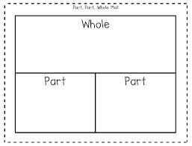

example cards: 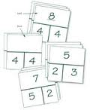

Number Bonds- example template: 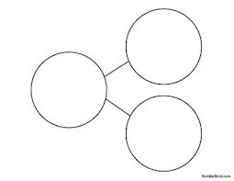

5

8



3

For some ideas: <http://www.pinterest.com/denisedunevant/math-part-part-whole/>

**Coherence and Connections: Need to Know**

Put Together/Take Apart situations with Both Addends Unknown play an important role in Kindergarten because they allow students to explore various compositions that make each number. This will help students to build the Level 2 embedded number representations used to solve more advanced problem subtypes. As students decompose a given number to find all of the partners (The two addends that make a total can also be called partners in Kindergarten and Grade 1 to help children understand that they are the two numbers that go together to make the total) that compose the number, the teacher can record each decomposition with an equation such as 5 = 4 + 1, showing the total on the left and the two addends on the right (For each total, two equations involving 0 can be written, e.g. 5 = 5 + 0 and 5 = 0 + 5. Once students are aware that such equations can be written, practice in decomposing is best done without such 0 cases.) Students can find patterns in all of the decompositions of a given number and eventually summarize these patterns for several numbers.

Equations with one number on the left and an operation on the right (e.g., 5 = 2 + 3 to record a group of 5 things decomposed as a group of 2 things and a group of 3 things) allow students to understand equations as showing various ways that the quantities on both sides have the same value. *MP6

Common Core Standards Writing Team. (2013, September 19). *Progressions for the Common   
 Core State Standards in Mathematics(draft). K-5 Counting and Cardinality and   
 Operations and Algebraic Thinking.* Tucson, AZ: Institute for Mathematics and   
 Educations, University of Arizona.

**K.OA.3** is connected directly to:

K.OA.1 Represent addition and subtraction with objects, fingers, mental images, drawings, sounds (e.g., claps), acting out situations, verbal explanations, expressions or equations.

K.OA.2 Solve addition and subtraction word problems, and add and subtract within 10, e.g., by using objects or drawings to represent the problem

K.OA.4 For any number from 1 to 9, find the number that makes 10 when added to the given number, e.g., by using objects or drawings, and record the answer with a drawing or equation.

K.OA.5 Fluently add and subtract within 5.

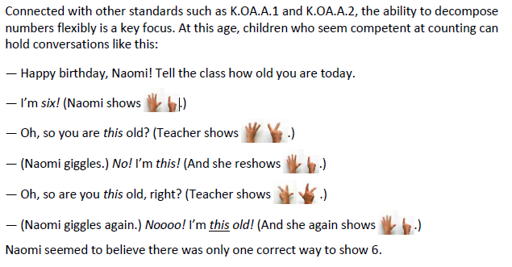

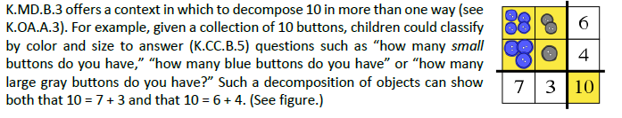

*PARCC Draft Model Content Frameworks: Mathematics Grades K-2* (2013, December).  
 Retrieved May 10, 2014, from <http://parcconline.org/sites/parcc/files/PARCCMCFMathematicsNovember2012V3_FINAL_0.pdf>

|  |  |
| --- | --- |
| Grade-Level | Grade Above |
| K.OA.2  **K.OA.3**  K.OA.4  K.OA.5  K.NBT.1 | 1.OA.6  1.NBT.2 |

**Classroom Resources**

K.OA.3 Daily Discourse

Differentiation: Allow struggling students to work with numbers equal to or less than 5 for a longer period of time. Have them build up to using numbers equal to or less than 10. Provide more opportunity with context problems. Allow students to work with objects and drawings.

Allow students who are excelling to three addends to equal a number 10 or less. (example: 1+2+4=7, 1+1+5=7, 1+3+3=7)

Daily Discourse Idea:

Did you know that 7 can be made up of smaller numbers? If I have 7 what 2 smaller numbers could make 7? Work with a partner.

I will collect all the answers. Let’s make sure we have all pairs of smaller numbers that make 7.

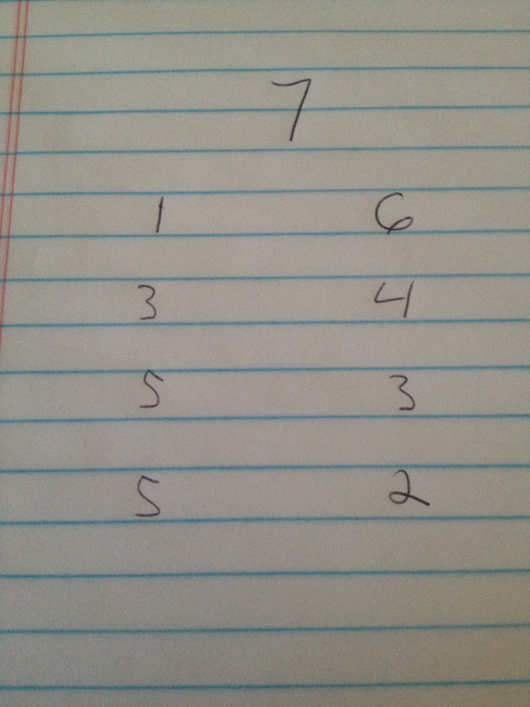

Are there any answers that do not make 7? Let’s make a drawing and count to make sure.

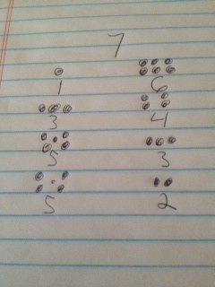

Can we count all together and make sure the total of the two smaller numbers equal 7?

Is there an answer that does not equal 7?

Educators can use the students in the classroom as manipulatives. Example: have kids create a group of 7. How many ways can they make a group of 7 using boys and girls?

**HOT Questions**

1. True or False: There are nine different combinations of numbers that when added together equal ten. Provide proof (drawing, objects, equation).
2. Create a drawing that shows all the combinations that total 8.
3. Using dominoes have students find all the dominoes that combine to a given number (between 0 and 10).

**Additional Resources**

Illustrative Mathematics  
<http://www.illustrativemathematics.org/illustrations/177>

<http://www.illustrativemathematics.org/illustrations/175>

<http://www.illustrativemathematics.org/illustrations/176>

<http://www.illustrativemathematics.org/illustrations/166>

<http://www.illustrativemathematics.org/illustrations/165>

<http://www.illustrativemathematics.org/illustrations/1408>

ISBE Mathematics Shift Kits  
<http://education.illinoisstate.edu/downloads/casei/math/7b.%20K%20SnapIt%20Task.pdf>

Inside Mathematics  
<http://www.insidemathematics.org/problems-of-the-month/pom-doubledown.pdf>

<http://www.insidemathematics.org/problems-of-the-month/pom-perfectpair.pdf>

Hawaii Tasks  
<http://standardstoolkit.k12.hi.us/hidden-pennies-k-oa-3/>

<http://standardstoolkit.k12.hi.us/balloons-k-oa-3/>

<http://standardstoolkit.k12.hi.us/apples-and-bananas-k-oa-3/>