Teacher Guide to Clarification

Instructional Math Materials

5.G.3

Classify two-dimensional figures into categories based on their properties

5.G.3 Understand that attributes belonging to a category of two-dimensional figures also belong to all subcategories of that category. For example, all rectangles have four right angles and squares are rectangles, so all squares have four right angles.
Attributes Belong to Both Categories and Subcategories

Example:
Create a Hierarchy Diagram using the following terms: Possible student solutions:
Polygons

Quadrilaterals

Rectangles Rhombi

Square
polygons – a closed plane figure formed from line segments that meet only at their endpoints.
quadrilaterals - a four-sided polygon.
rectangles - a quadrilateral with two pairs of congruent parallel sides and four right angles.
rhombi – a parallelogram with all four sides equal in length.
square – a parallelogram with four congruent sides and four right angles.

According to PARCC a trapezoid is defined as “A quadrilateral with at least one pair of parallel sides.”
Can you classify a triangle with more than one name? Yes by sides and angles
Are parallelograms trapezoids? Yes according to the PARCC definition because a trapezoid is defined as “A quadrilateral with at least one pair of parallel sides.” A Parallelogram has two pairs of parallel sides so that is more than one!
Do all quadrilaterals have opposite angles congruent or only certain ones? Not All
- How many lines of symmetry does a regular polygon have?
The number of lines of symmetry in regular polygons is equal to the number of sides it has.

Coherence and Connections: Need to Know

Grade Below | Grade-Level | Grade Above
3.G.1  4.G.2 | 5.G.3  5.G.4 | None

Evidence  Statement Key | Evidence Statement Text | Clarifications | MP
5.G.3  EOY | Understand that attributes belonging to a category of two- dimensional figures also belong to all subcategories of that category. For example, all rectangles have four right angles and squares are rectangles, so all squares have four right angles. | i) A trapezoid is defined as “A quadrilateral with at least one pair of parallel sides.” | 7, 5

PARCC Mathematics Evidence Tables. (2013, April). Retrieved from:
http://www.parcconline.org/assessment-blueprints-test-specs

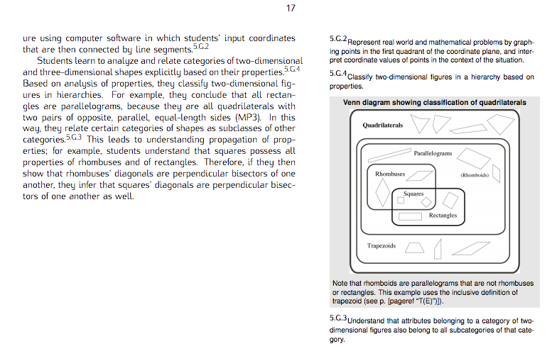
Common Core Standards Writing Team. (2012, June 23). Progressions for the Common
Core State Standards in Mathematics(draft). K-6 Geometry. Tucson, AZ: Institute for
Mathematics and Educations, University of Arizona.

Classroom Resource

5.G.3 Daily Discourse
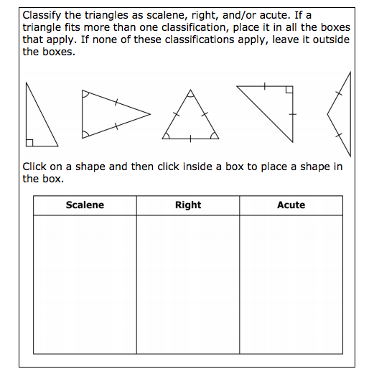
http://www.doe.k12.de.us/commoncore/math/teachertoolkit/sbac5.pdf

HOT Questions
Sort the 14 shapes using the Venn diagram.

Is a quadrilateral Is a parallelogram

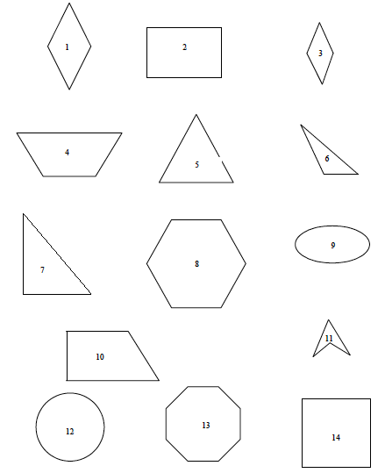

Did Lauren Classify the polygons correctly? Justify your answer.
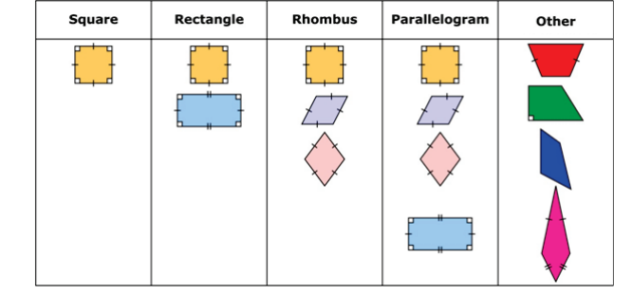

PARCC sample EOY TEST http://practice.parcc.testnav.com/
Number 7

Illustrative Mathematics
https://www.illustrativemathematics.org/illustrations/1505
Inside Mathematics
http://www.insidemathematics.org/assets/common-core-math-tasks/sorting%20shapes.pdf
Howard County WikiSpace
https://grade5commoncoremath.wikispaces.hcpss.org/Assessing+5.G.3
NCTM Illuminations
http://illuminations.nctm.org/Lesson.aspx?id=665
New York City Department of Education
http://schools.nyc.gov/NR/rdonlyres/B8B8BDAD-2EF2-4BF8-AE93-114C48B563E2/130938/NYCDOEG5Math_TimeforRecess_Final.pdf

